

**Smarter Balanced**

**Assessment Consortium:**

**Support Tool User Guide**

August 29, 2018

**Table of Contents**

Overview of the Test Delivery System Support Tool 3

Introduction to This User Guide 4

Key Icons and Elements 5

Other Resources 5

Section I. Accessing the Support Tool 6

Accessing the TDS Support Tool 6

Section II. Test Package Loader 7

Test Package Loader Access Requirements 7

Test Package Jobs Page 8

Job Statuses 9

Loaded Test Packages Page 11

Deleting a Test Package 12

Test Package Upload Page 12

Loading and Configuring a Test Package - Step by Step Example 14

Test Package Loader Troubleshooting 14

Test package load fails 14

Test package loads successfully, but tools appear to be missing 15

Section III. Scoring Validator 16

Scoring Validation Jobs Page 16

Upload Test Results Page 17

Re-scoring Jobs Status Panel 19

Job Action Buttons 20

Scoring Validation Report 21

# Overview of the Test Delivery System Support Tool

The Support Tool application is a web application that contains a number of useful administration tools. Currently, the Support Tool has two primary features – the Test Package Loader and the Scoring Validator

# Introduction to This User Guide

This user guide provides information about the Test Delivery System Support Tool, including the Test Package Loader and the Scoring Validator.

This introduction describes the contents of this document and includes a key for identifying icons and elements.

Each section begins on a new page, which allows for easy printing.

* **Section I, Accessing the Support Tool**, explains how to access and log in to the Support Tool
* **Section II, Test Package Loader Scoring**,
* **Section III, Scoring Validator**, explains how to create rescoring jobs by uploading Test Transmission Reports (TRTs) and viewing the rescoring results

## Key Icons and Elements

|  |  |
| --- | --- |
| Icon | Description |
|  | **Warning:** This symbol appears with text that contains extremely important information regarding actions that may cause errors. |
|  | **Caution:** This symbol appears with text that contains important information regarding a task. |
|  | **Note:** This symbol appears next to text that contains helpful information or reminders. |
|  | Text that appears in gray boxes provides instructions relevant to the task described.   * Numbered (ordered) lists provide step-by-step instructions. * Bulleted lists provide instructions that do not need to be done in a specific order. |
| [Text] | Text in brackets is used to indicate a link or button that is clickable. |

## Other Resources

Administration manuals and other related documents for administering the Smarter Balanced Assessments are available on your state’s website.

Technology requirements are outlined on the Smarter Balanced website’s [Technology](http://www.smarterbalanced.org/assessments/testing-technology/) page. This page contains information about supported hardware and operating systems for accessing the Operational and Practice and Training Tests.

The *Technical Specifications Manual for Online Testing* contains information about installing the secure browser and configuring district and school networks to ensure that students can access the secure Student Testing Site. This document is available in your state’s website.

# Section I. Accessing the Support Tool

The Support Tool is a secure site. To log in, you must have an authorized username and password. If you have not yet received an email with your account information, contact your District or School Test Coordinator (as applicable).

## Accessing the TDS Support Tool

|  |  |
| --- | --- |
| 1. Open your Web browser and navigate to the Support Tool portal (URL) provided by your District or School Test Coordinator. |  |
| 1. If you are not already logged in, you will be directed to the Single Sign On login page.   *The Single Sign On system allows you to log in to multiple Smarter Balanced systems. After logging in, you can switch between systems without having to log in and out of each system.* |  |
| 1. Type your username and password in the respective text boxes and click [**Log In**]. See Figure 1. You will be directed to the system you selected.   *If you have forgotten your password, refer to the* ART User Guide *for instructions on resetting it.* | Figure 1: Login Screen |

# Section II. Test Package Loader

The Test Package Loader, Figure 2, is an application that can be used to easily load and delete test packages into various systems simultaneously. The Test Package Loader interacts with the Test Delivery System (via the Assessment Service), the Test Integration System (TIS), the Administration & Registration Tools system (ART), and the Teacher Hand-Scoring System (THSS). The Test Package Loader is compatible with the Enhanced Test Package format. The XML Schema Definition (XSD) for the latest Test Package Specification can be located [here](https://github.com/SmarterApp/TDS_SupportTool/blob/develop/client/src/main/resources/xsd/v4-test-package.xsd).

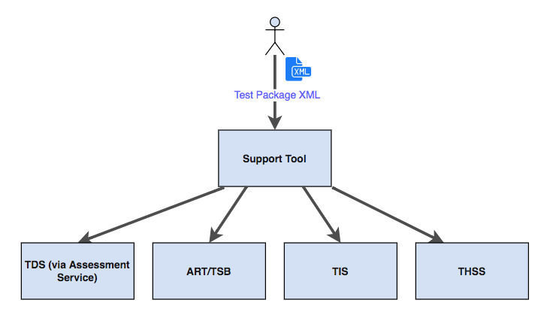

Figure 2: Test Package Loader Diagram

## Test Package Loader Access Requirements

The user logged into the Support Tool must have either the **Support Tool Admin** role or the **Support Tool Test Package Admin** role in order to have access to the Test Package Loader portion of the Support Tool. Please refer to the deployment checklist for more details on how to configure roles and permissions for the Support Tool. If the user has the proper role, the “Test Package Loader” link should appear on the top portion of the Support Tool application, as shown in Figure 3.



Figure 3: The Test Package Loader Link

## Test Package Jobs Page

The home page of the Test Package Loader is also referred to as the Test Package Jobs page, Figure 4. This view contains two main sections – the list of all test package load, delete, and rollback jobs, and a details pane below it. When a job is selected from the list in the top pane, more details specific to that job will be displayed in the pane below. Additionally, the selected job will be highlighted in blue in the job list. A search bar is also present above the test package job list that can be used to search for jobs based on their Job ID or the Test Package name.

There are three types of Test Package jobs:

1. **Load Jobs** – These types of jobs are created when a Test Package XML file is uploaded to the Support Tool. After processing the file, this type of job will attempt to load the test package into one or more external systems
2. **Delete Jobs** – A delete job can be executed from the “Loaded Test Packages” screen. This type of job will delete and clear out any data pertaining to the selected Test Package. Please note that if a Test Package contains more than one test, all tests associated with that Test Package will be removed from the targeted systems
3. **Rollback Jobs** – These jobs are triggered automatically when a Load job fails for any of the external systems. Rollback jobs are functionally equivalent to Delete Jobs – with the difference being that Delete jobs are always manually executed, while Rollback jobs are executed automatically by the Support Tool. Please note that a Rollback will NOT be triggered if the Load job fails at the validation or TDS load step.

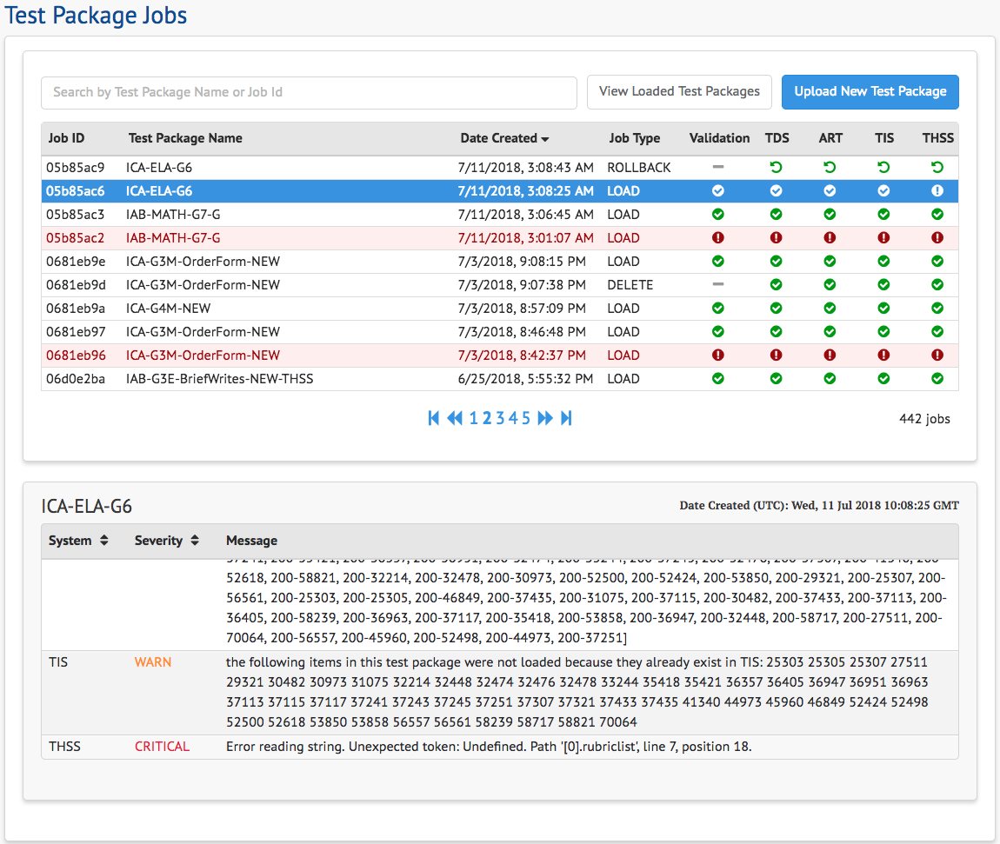

Figure 4: Test Package Jobs Page

Each job contains various steps, which typically have an external target system associated with them. In the case of a load job, for example, a user can choose to upload into TDS and ART, but not any of the scoring systems (TIS or THSS). Please refer to the **Upload Test Packages View** section for more details on uploading test packages. For load jobs specifically, a validation step is executed to verify that that uploaded test package is valid with regards to the Test Package XML Schema Definition (XSD). During the validation step, some warnings and/or errors may be reported. If any critical validation errors are encountered, the load job will be aborted and any identified errors will be displayed in the details pane. Refer to Figure 4 for an example of a selected test package load job that contains validation warnings and a critical error.

### Job Statuses

Test Package job steps each have their own individual status, which when combined will dictate what the overall job status is. If, for example, a user attempts to load a test package into all systems, and the TIS load fails, the entire job is considered to have failed, even if the other steps (loading into THSS, ART, and TDS) were successful. Please refer to Table 1 for more details regarding possible job step statuses.

|  |  |  |
| --- | --- | --- |
| Icon | Status | Description |
|  | Not Applicable | This status is typically used when a certain system has been purposefully “skipped”, or when a step does not apply to a specific loader job. For example, there is no “Validation” necessary for delete or rollback jobs. |
|  | In Progress | Indicates that a job step is in the process of executing |
|  | Success | A green checkmark indicates that the step was successful |
|  | Fail | A red circle with an exclamation mark indicates that the step failed. More details can be found in the bottom pane when the job is selected. |
|  | Rollback (Successful) | This status only occurs for rollback jobs – when a particular system’s load is successfully rolled back |
|  | Pending | This status indicates that a step has not yet began execution and is still pending. If the icon appears red, this would indicate that an earlier step in the execution flow failed, and this job step will not be reached. |

Table 1: Possible Job Status Icons and Descriptions

## Loaded Test Packages Page

The Loaded Test Packages page, Figure 5, contains a table that shows all test packages that have been loaded into any systems via the Support Tool Test Package Loader application. In this view, you can see the current “state” of each test in each system. Additionally, test packages can also be deleted from any of the systems that test package has been previously loaded into.

For example, in Figure 4, we can see that the test package **SBAC-IAB-FIXED-G7E-ReadLit-ELA-WT3** has been successfully loaded into all four external systems. The package **G11M-AlgLin-Winter-HTQA**, however, has only been loaded into TDS and ART.

**Please Note:** The Loaded Test Packages page will not contain any tests that may have been previously loaded into the system without the Support Tool.

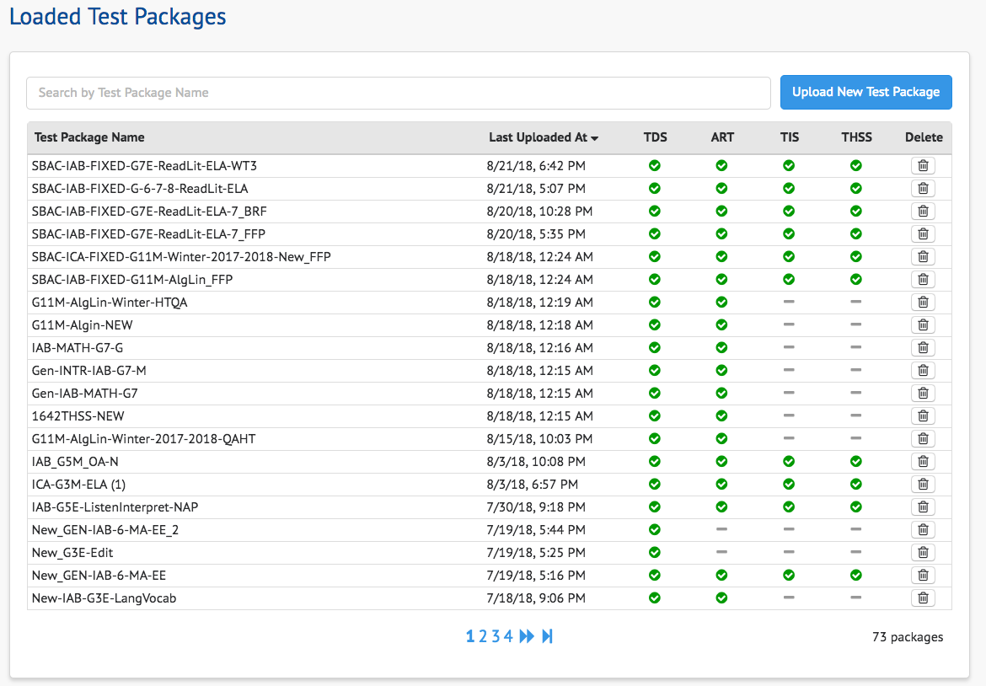

Figure 5: The Loaded Test Packages Page

### Deleting a Test Package

The right-most column in the Loaded Test Packages page, Figure 6, contains a button for deleting test packages. This action will remove the test package from any system that the test package had been loaded into.



Figure 6: Loaded Test Packages Page

After confirming the deletion of the test package, a new Delete job will be created. The status of that job can be observed in the Test Package Jobs page.

## Test Package Upload Page

The Test Package Upload page, Figure 7, is the area of the application where one or more test packages can be uploaded at a time. Although more than one test package can be uploaded at a time, an individual Load job will be created for each test package that is uploaded.

Test package XML files can either be drag-and-dropped or browsed to and selected. Please note that the actual upload jobs will not be executed until the blue **Create Upload Jobs** located at the bottom right is clicked. If a file is selected for upload by mistake, the file can be removed from the “Pending Test Package Loader Jobs” list by clicked on the red “Remove” button to the right of the filename.

During the upload, a user can choose not to upload the test package into ART or the other Scoring systems. For example, if TIS and THSS is not configured in the deployment environment, a Support Tool Administrator may choose to only load test packages into ART and TDS. If any systems are chosen to be skipped, a dash icon will be shown for those particular steps (please refer to the table in the “Job Statuses” section of this user guide).

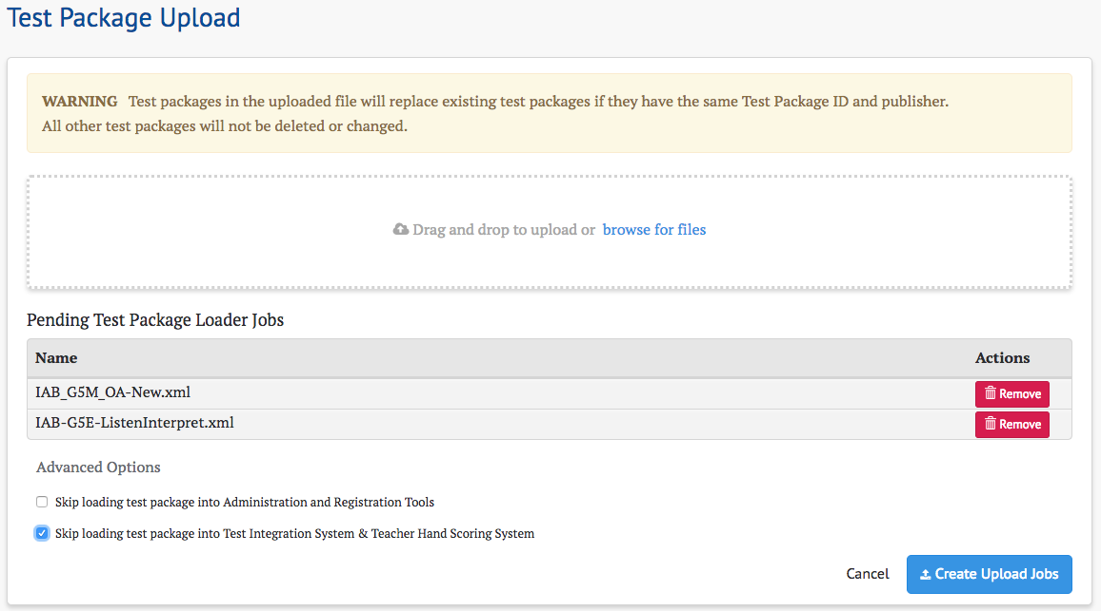

Figure 7: Test Package Upload Page

Once the **Create Upload Jobs** button has been clicked, a Load job will be created for each of the selected test packages. The user will be redirected back to the Test Package Jobs view where each job’s progress will be displayed.

## Loading and Configuring a Test Package - Step by Step Example

1. Log into the Support Tool using a user with a role that can access the Test Package Loader (see the **Test Package Loader Access Requirements** section for more information)
2. Click the blue **Upload New Test Package** button to navigate to the upload screen.
3. Drag-and-drop or select the test package to upload. More than one test package can be uploaded at a time.
   1. Optional: Select one of the Advanced Options checkboxes if you wish to skip loading into ART and/or any of the scoring systems.
4. Click the **Create Upload Jobs** button to begin the upload process.
5. You should be redirected back to the Test Package Jobs page. Here you can observe the job’s status as it progresses through each upload step. If the upload is successful, green checkmarks will be displayed in each of the five job steps.
   1. If any of the steps result in an error (represented by a red exclamation mark icon), please refer to the **Test Package Loader Troubleshooting** section in this document.
6. Once the upload is successful, all that’s left to be done is to configure the assessment window in ART. Please note that if a test package has more than one test, each test’s test window will need to be configured individually. Please refer to ART User Guide found here for more information on how to configure test windows: <http://www.smarterapp.org/documents/Administration_and_Registration_Tools_User_Guide.pdf>

## Test Package Loader Troubleshooting

Below are some examples potential issues that may be encountered and common troubleshooting steps for dealing with potential deployment, configuration, or test package related issues.

#### Test package load fails

If a test package upload job fails, the first step is to identify which job step contained a failure, and to get more information as to why the failure occurred. Most commonly, a malformed test package will fail during the validation process – the first step in the load job’s execution. Validation should report which particular element or attribute is causing the failure. In some cases, a test package may validate successfully, but other configuration, data conflicts, or connectivity problems can be encountered.

For example, if a failure occurred in ART, and the error reported in the jobs detail pane is a 404 (Not Found), a reasonable follow-up step would be to confirm that the ART system is in fact running and properly configured to accept incoming requests from the Support Tool.

Other more generic system-specific errors:

* TDS (Assessment Service) – 422 Unprocessable Entity
  + This error typically related to a misconfigured Test Package with an error that is not being identified by the Validation step. Please contact an administrator so that he can troubleshoot the error further.
* TIS – 500 Internal Server Error
  + Can occur when there is an issue with how Scoring data is configured within the test package. Please contact an administrator so that he can troubleshoot the error further.

In general, if a test package in the new format shares a unique identifier (either at the test level, segment level, or form level) with a test package that existed before the installation of Support Tool, some unexpected behavior may be encountered and data between the two separately uploaded test packages may conflict.

#### Test package loads successfully, but tools appear to be missing

The first step in this scenario is to ensure that the test package XML contains the Tools that are expected to be loaded into the system, and that the tool names and codes are properly configured. The Test Package Loader is flexible and will allow any string values to be used as Tool names and option codes. However, any unrecognized tool names or option codes will be identified as a “WARNING” during the validation step. Please note that tool names and tool option codes are case-sensitive, and using a non-ISAAP compliant feature codes. See <http://www.smarterapp.org/documents/ISAAP-AccessibilityFeatureCodes.pdf> for more information on compatible tools and tool codes. If the tools still do not appear in the student or proctor applications, please contact an administrator.

# Section III. Scoring Validator

This section contains information on how to submit Test Result Transmission files for rescoring, and how to view the results of the rescoring when it is done.

## Scoring Validation Jobs Page

If you are not already on the Scoring Validation Jobs page, Figure 8, navigate to it by selecting the "Scoring Validator" link at the top of Support Tool. Depending on your user authorities, this may be the only navigation link.

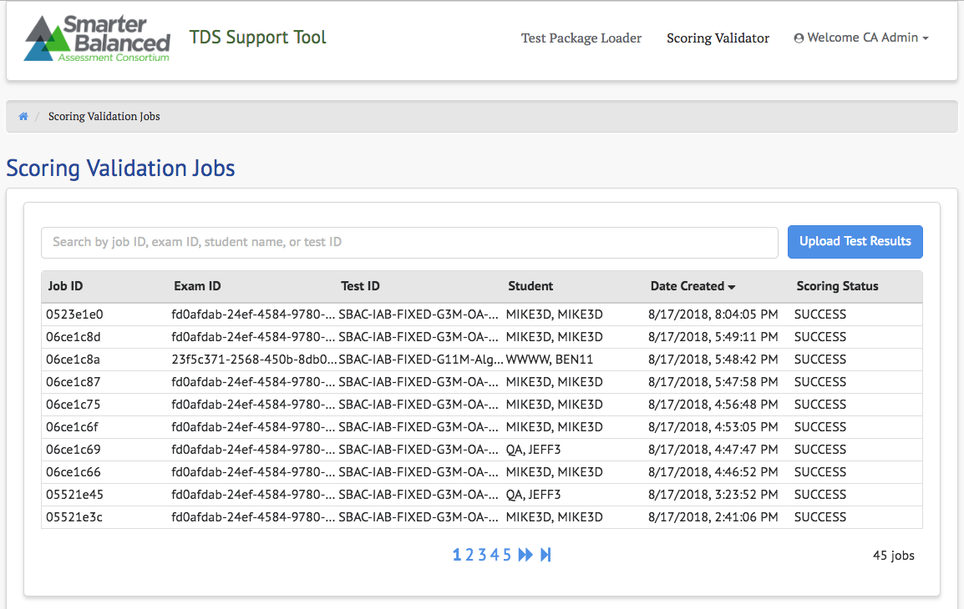

Figure 8: Scoring Validation Jobs Page #2

The jobs submitted by the currently logged in user are displayed. By default, they are sorted by Date Created descending, as indicated by the downward pointing triangle next to the Date Created column header. Selecting any column header will cause the job table to be sorted by that column instead. Repeatedly selecting a column header will toggle the sort between ascending and descending.

More values can be viewed by using the pagination controls under the table. The table contents can also be filtered by typing key words or characters into the search bar above the table.

The table columns are:

* Job ID: a shortened version of the unique ID assigned when the re-scoring job was submitted
* Exam ID: the unique ID for the exam or opportunity
* Test ID: the test ID of the exam
* Student: name of student
* Date Created: the date and time the job was submitted
* Scoring Status: status of the rescoring process

|  |  |
| --- | --- |
|  | **Reminder:** Only Job ID, Exam ID, Test ID, and Student are searched for the keywords in the search box. It is not possible to filter by Date Created or Scoring Status. The column sorting should be used instead. |

The following scoring status values are possible:

* SUCCESS: the re-scoring process has completed successfully, and results are ready to view
* FAIL: the re-scoring process cannot be completed because of an error
* FAIL - EXPIRED: the re-scoring process did not return results before the timeout period
* IN PROGRESS: the re-scoring process is still working on the job

## Upload Test Results Page

To submit one or more new re-scoring jobs, select the Upload Test Results button next to the search text box. This will display the Test Results Upload page, Figure 9.

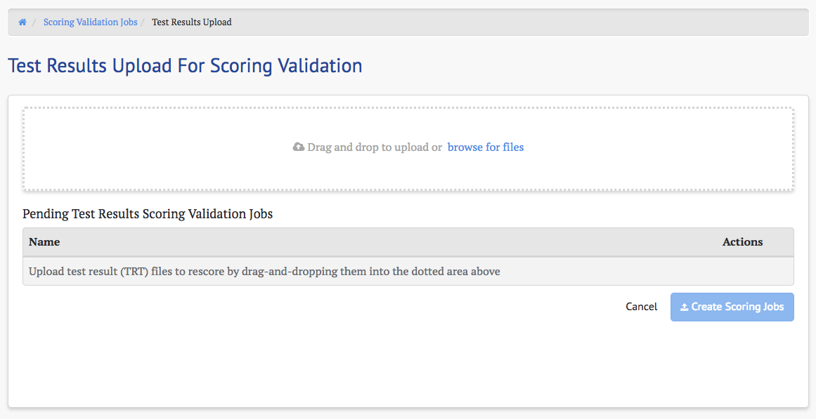

Figure 9: Test Results Upload Page

You can either drag files from your File Explorer or Finder window into the upload box, which is indicated by the dotted outline, or select the "browse for files" link to display a file chooser dialog. A combination of these methods can be used to select multiple files. All selected files will appear in the table in the Pending Test Results Scoring Validation Jobs view, Figure 10.

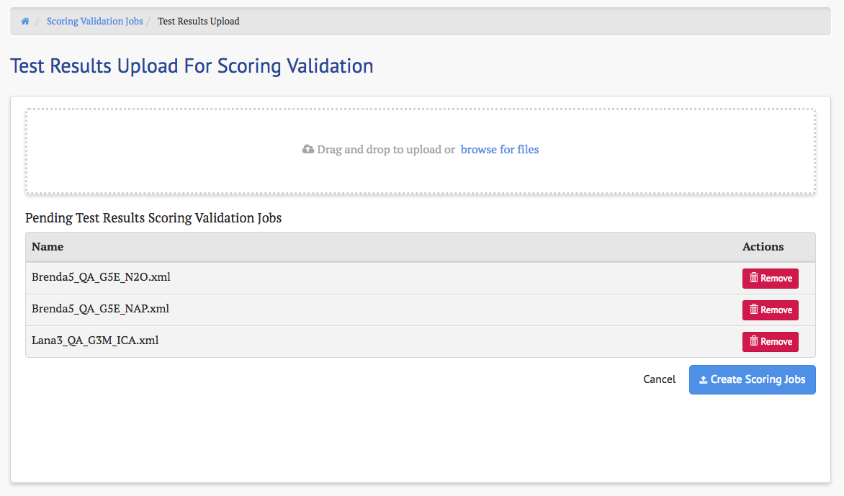

Figure 10: Pending Test Results Scoring Validation Jobs View

|  |  |
| --- | --- |
|  | **Reminder:** Only properly-formatted, valid TRT files can be re-scored. Any other files will cause the re-scoring job to fail. |

Individual files can be removed by selecting the Remove button next to its entry in this table. Selecting the Cancel button will abort the process without uploading any of the selected TRTs. To submit all the selected TRTs for re-scoring, select the Create Scoring Jobs button.

|  |  |
| --- | --- |
|  | **Note:** Files removed by selecting their Remove buttons are only removed from list of files to submit for re-scoring. They will not be deleted from your system. |

When Create Scoring Jobs is selected, the display will return to the Scoring Validation Jobs page, Figure 11, and the newly uploaded TRTs will appear as individual jobs at the top of the table.

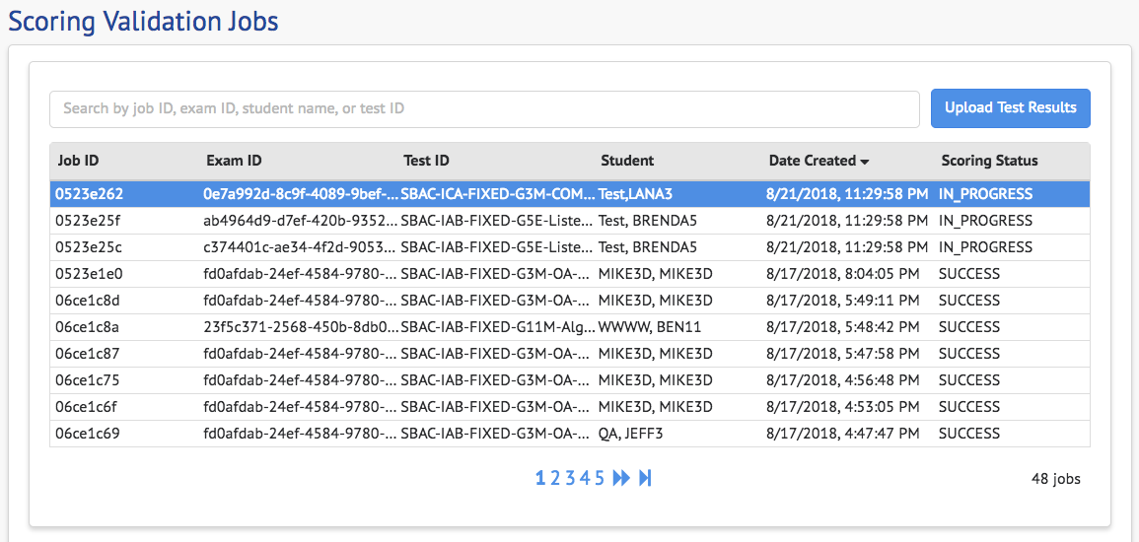

Figure 11: Scoring Validation Jobs Page #2

The status of these jobs will be IN PROGRESS, but will change to SUCCESS when the re-scoring process completes.

## Re-scoring Jobs Status Panel

Selecting a row in the jobs table will populate a panel with that job's status details, Figure 12.

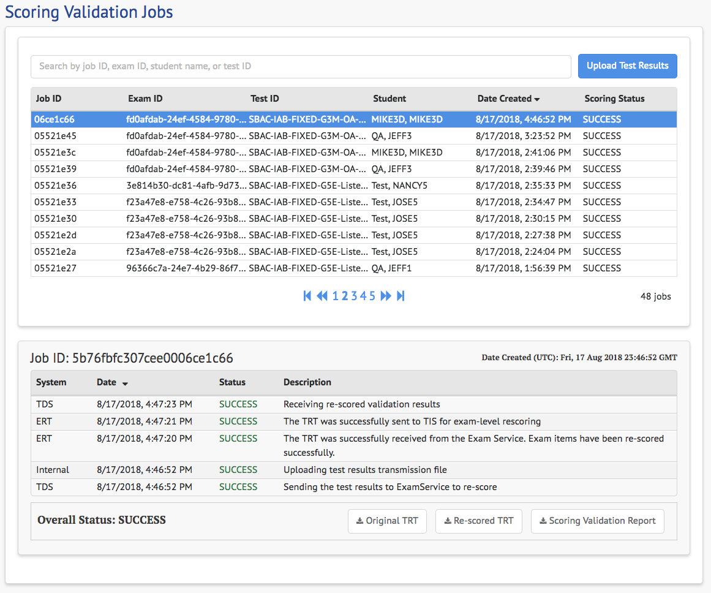

Figure 12: Re-Scoring Jobs Status Panel

This panel will display the full Job ID, which is shown in a shortened form in the selected row. Under this is the job steps table, which contains details of each step in the re-scoring process. It displays the system that performed the step, the date and time it was performed, the status of the step, and a description of the work performed. When all the steps have completed with SUCCESS status, the Overall Status of the job will also be SUCCESS.

### Job Action Buttons

The three buttons that appear under the job steps table have the following actions:

* Original TRT -- downloads the TRT that was uploaded to submit the rescoring job. This button is enabled as soon as the Internal "Uploading test results transmission file" step is successful.
* Re-scored TRT -- downloads the re-scored TRT. This button is only enabled when the job's overall status is SUCCESS.
* Scoring Validation Report -- displays exam and item score differences between the original and rescored TRT. (See next sub-section for details.) This button is only enabled when the job's overall status is SUCCESS.

### Scoring Validation Report

The Scoring Validation Report, Figure 13, show differences in exam and item scores between the originally uploaded TRT and the re-scored TRT.

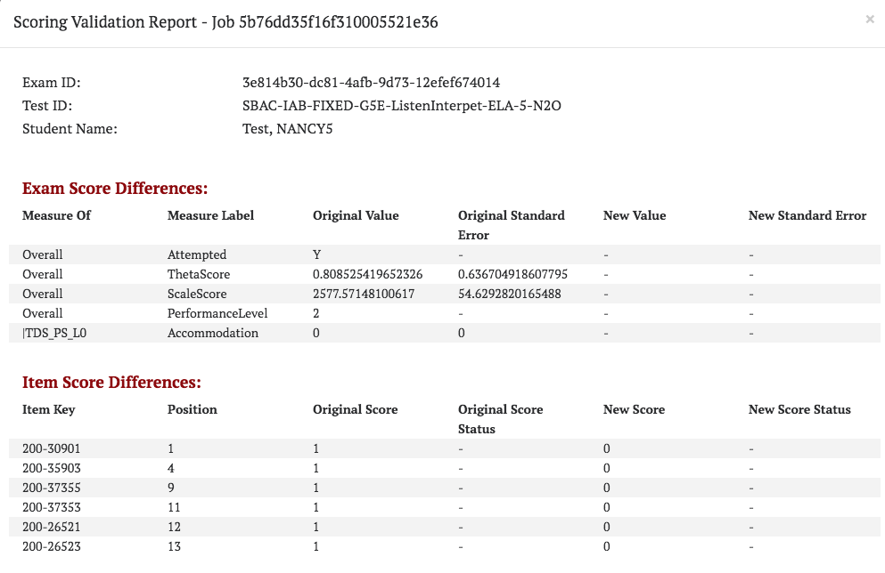

Figure 13: Scoring Validation Report

The initial columns of each of the Exam Score Differences and Item Score Differences identify the particular element being compared, and the remaining columns identify which values changed. Only exams scores and item scores with changes will appear in one of these tables. If the re-scoring process did not change any item scores, then the Item Score Differences table will not appear in this report, and if it did not change any exam scores, then the Exam Scores Differences table will not appear. If no item score or exam scores were changed on re-score, then neither table will appear, and instead a message will say that no changes were found.